**LEVEL 1**

Case for internal HDD (not sure about how I describe them ,due to not using of “As…I want…for”. And I had trouble with sorting between funtional/non-functional, because case should contain, protect and connect HDD to device )

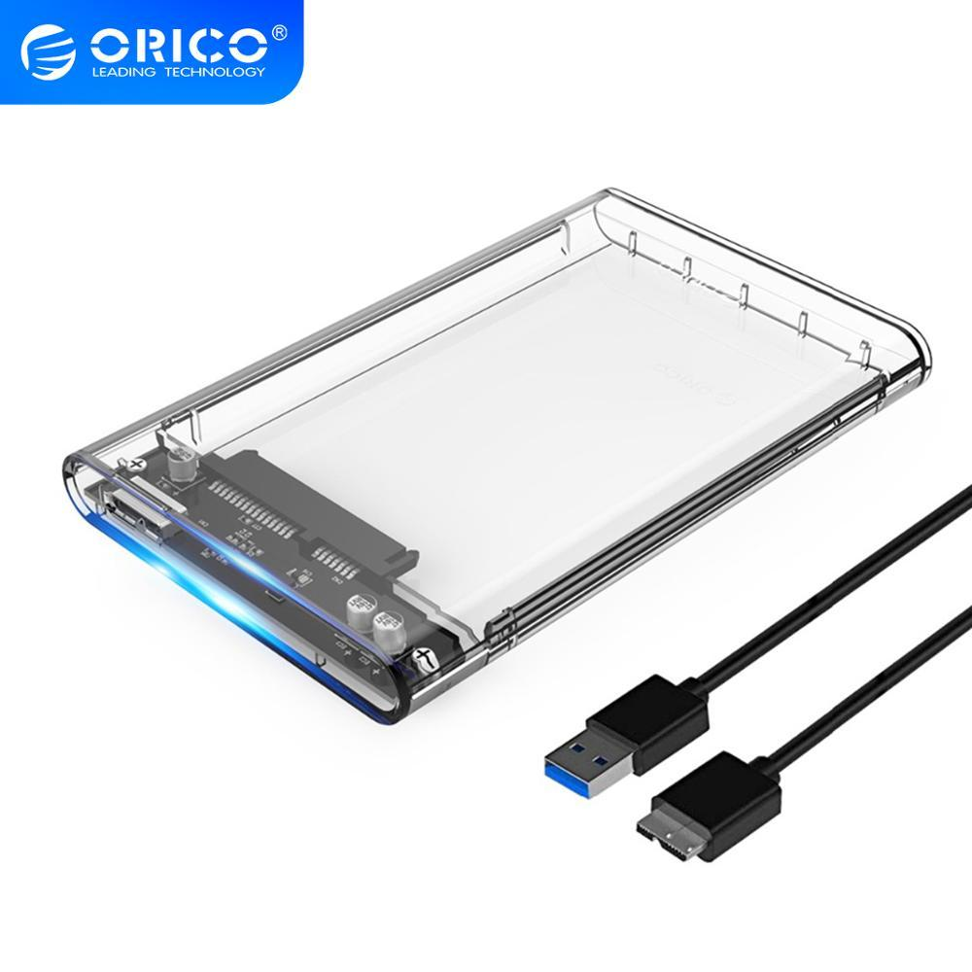

**Functional:**

* Connection of HDD must be performed with SATA->USB-A cable
* It must support 2.5inch SATA I/II/III connection
* It must prevent ingress of dust and dirt inside case box with IP3 standard
* Must contain backward compatible with USB 2.0 or 1.1 ports
* Data transfer speed should be upto 5 Gbps via USB chord
* Maximum capacity per bay should be 4TB (included)

**Non-functional**:

* Physical connection of HDD and ports should be stable during physical translation of case box
* Internal space must be suitable for 2.5-inch 7mm/9.5mm HDD
* Size of case should be 12.5 x 8 x 1.5 Centimeters
* Material for case should be transparent plastic
* The size of cable must be 50 cm (including plugs)

**LEVEL 2**

If we talk about the maximum quality of the final result (and we mean by “final result” – our product), then the peer review technique can be used to revise requirements. By itself, it divides into 3 options, but if we want an accurate and the most not deviated SRS, we can use formal inspection.

It has a structured, systematized, and documented approach to document review requirements, viewed by a large group of specialists documenting all comments. Of course, from minuses, we would have a slow implementation due to a large number of specialists involved. But, with this kind of review, we can totally get the maximum from the SRS review